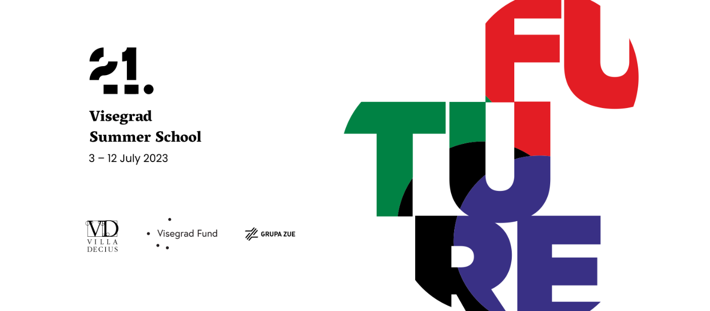

Visegrad Summer School is a 10-day program that educates and integrates young people from V4, CEE and WB countries in terms of policy, new technologies and trends, cultural management, human rights and universal tolerance. During this year's edition of the VSS, 30 participants will attend workshops and development lectures focused on future trajectories, new technologies and cultural management. During the project, students will have the opportunity to attend lectures, workshops, and discussions on various topics.

This year very special emphasis is on the Human Rights and their place and role in contemporary world in any aspect. The second perspective for the programme is future and competences that allow to predict is and compose scenarios and strategies for development. Project will be held between the 3rd and the 12th of July, in the Villa Decius in Krakow.

The Visegrad Summer School is an excellent opportunity to network with like-minded individuals from all over the world, exchange ideas, and broaden their horizons. Participants will be able to learn from experienced professionals in their fields and gain practical skills that will help them in their future careers.

More information are available at: https://www.visegradsummerschool.org/how-to-apply-2017

The application form is available at the link: https://forms.gle/tMUZABvjC1HeX1US9

For any additional questions, you can contact the following email: summerschool@villa.org.pl
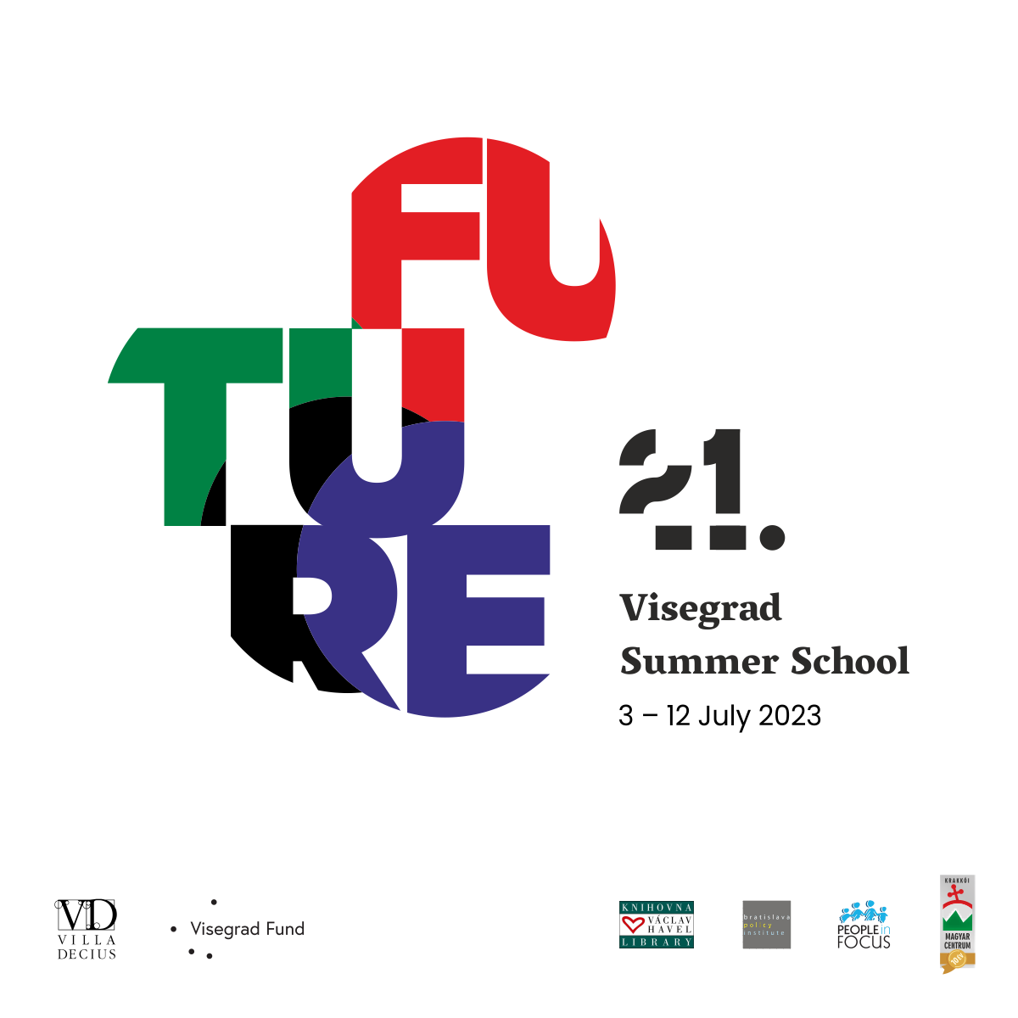

POST on FB:

Visegrad Summer School is a 10-day program that educates and integrates young people from V4, CEE and WB countries in terms of policy, new technologies and trends, cultural management, human rights and universal tolerance.

During this year's edition of the VSS, 30 participants will attend workshops and development lectures focused on future trajectories, new technologies and cultural management.
The main goal of the 21. VSS is to build the capacity of progressive thinking on future.

So if:
- you are interested in new technologies, AI, current geopolitical situation, cultural heritage, human rights and future trajectories, and you want to test yourself and exchange views in an international group of participants APPLY
- you want to take your first steps as an entrepreneur, start-up creator, or as a cultural manager APPLY
- you enjoy meeting new people with similar interests, expanding your horizons, making friends and building professional networks APPLY

Recruitment is open, and we look forward to receiving your applications!
To apply, simply fill out the form available at the link:
https://forms.gle/hxXDRccTQncz5nzR6

If you have any questions, please write to us in a private message!
More info: https://www.visegradsummerschool.org/how-to-apply-2017

