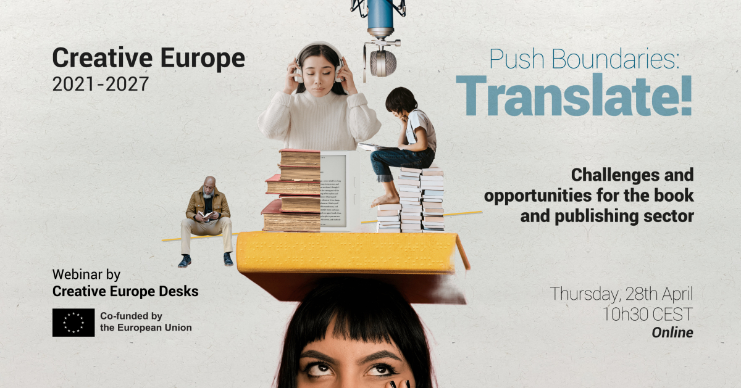
Save the Date!
In the framework of the currently open call for projects Circulation of European Literary Works, the Creative Europe Desks are teaming up to organize a webinar dedicated to the challenges and opportunities for the book and publishing sector:
Push Boundaries: Translate !
Webinar
Thursday 28th April 2022 / 10.30 CEST
How to make European fiction cross-borders? How to tackle the needs of the book sector in terms of internationalisation? How to assure that translation becomes a means of bridging linguistic barriers and foster access to cultural diversity, while guaranteeing fair remuneration for authors and translators?
To answer these questions, we will look into the opportunities for the sector in the framework of the new Creative Europe programme 2021-2027, with a focus on the dedicated sectorial call, together with representatives of the European Education and Culture Executive Agency (EACEA). The programme manager of the book sector at the European Commission will give an essential update on the policy framework and the recently published OMC group report Translators on the Cover. And with invited experts we will look at the crucial needs for the sector in terms of internationalization.
Guest Speakers: Arnaud Pasquali (European Commission Programme Manager - Book sector), Corinne Rigaud (European Education and Culture Executive Agency, Head of Sector), Arturo Peral (Literary Translator), Polona Konjedic (EACEA) and Literary consultant and LIT call evaluator)
The detailed programme will follow shortly.
Link for registration here.
This webinar is a joint initiative of Creative Europe Desks from Belgium, Denmark, Italy, Luxembourg, Portugal, and The Netherlands.

